The title of the report: Lab 2 Forces on plates

Student name

Student ID number

OBJECTIVE
To determine the forces of static fluid on plates using Matlab engineering software

BACKGROUND
The following problem is solved using Matlab software engineering. In the figure shown below is tank filled with static fluid(water). At the bottom there is an outlet pipe and a seal the prevent water from flowing out. In order to open the water outlet a winch is used to pull the seal open. For each of the cases whose description is given, the amount of force used to open the winch is calculated
CASES:
Case#1:
Fluid type: Water
Circular gate diameter is 10 inches.
Angle of inclination varies from 20⁰ to 40⁰ in increments of 5⁰
Plot the resultant force F_{r} of the fluid versus the angle of inclination.
Plot Y_{R} verses the angle of inclination
Plot X_{R} verses th angle of inclination.
Case #2
Fluid type: machine oil with S.G.=0.915
Circular gate diameter varies from 8 inches to 20 inches in increase of 2 inches
Angle of inclination stays constant at 30⁰
Plot the resultant force F_{r} of the fluid versus the gate diameter.
Plot Y_{R} versus the gate diameter
Plot X_{R} versus the gate diameter
Case #3:
Fluid type: liquids listed in table B.1
Circular gate diameter is 10 inches.
Angle of inclination is 30⁰
Plot the resultant force F_{r} of the fluid versus the S.G. of the liquids.
Plot Y_{R} versus the S.G. Of the liquids.
Plot X_{R} versus the S.G of the liquids.
Which of the liquids has the largest Fr value and which one has the smallest?
Turn in: plots, a sample circulation for each case,

Problem #2
For the following figure determine, the resultant force (Fr) caused vy the fluid on the plate and center of pressure of the force (Lp), defined as the inclined distance from the surface to where the force Fr acts. The plate is inclined as:
- Shown in the figure
- Flipped over 90 degrees
- Flipped over 180 degrees
Determine which position is the better one for this plate?
A formal report needs to be written for this laboratory and the above questions need to be answered are answered for each case.

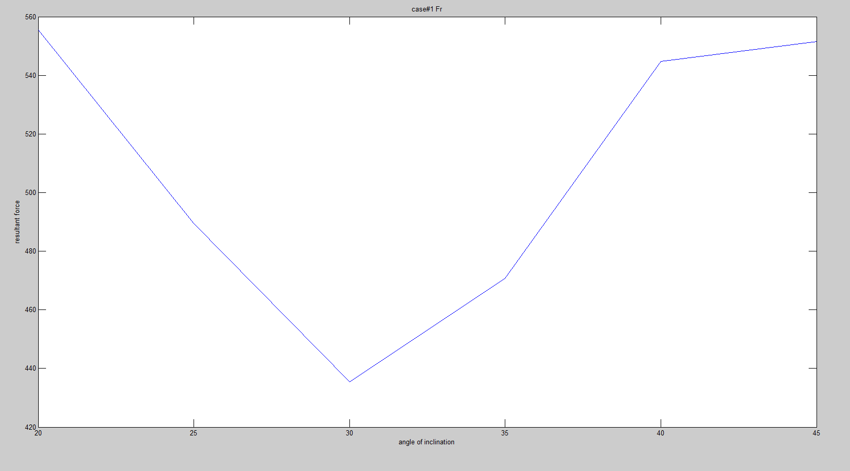
Figure 1 plot of the Fr against a

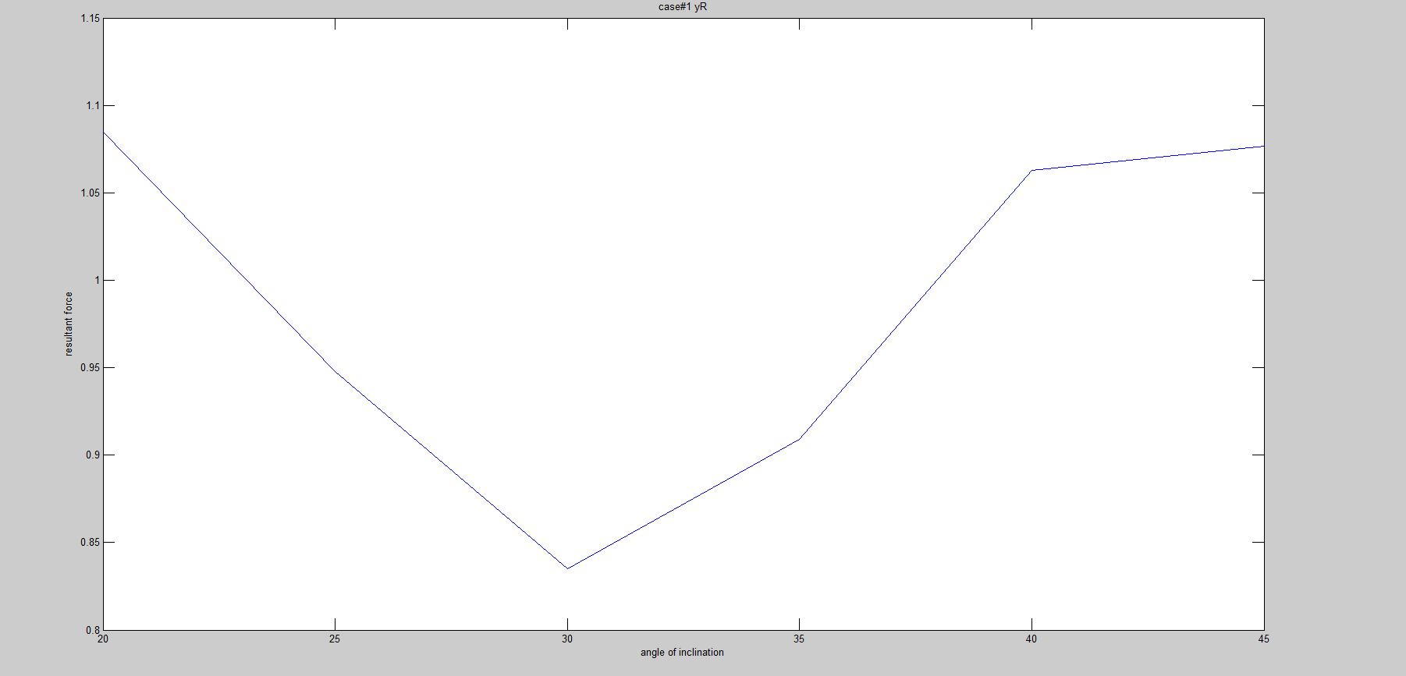
Figure 2

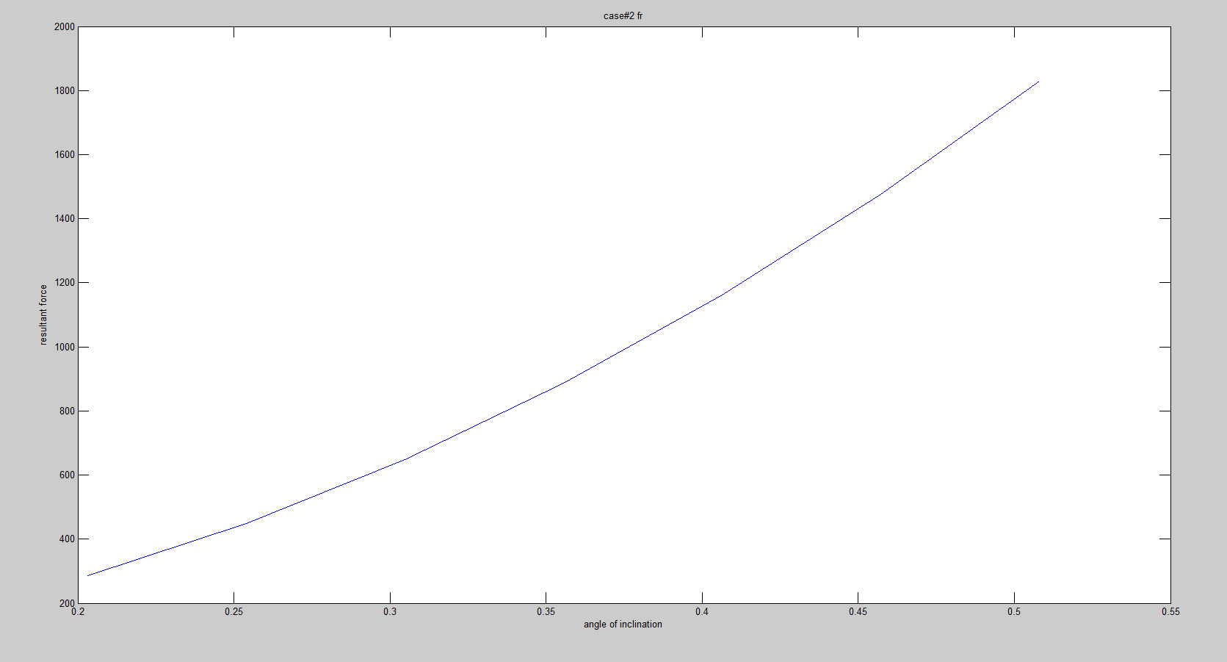
Figure 3

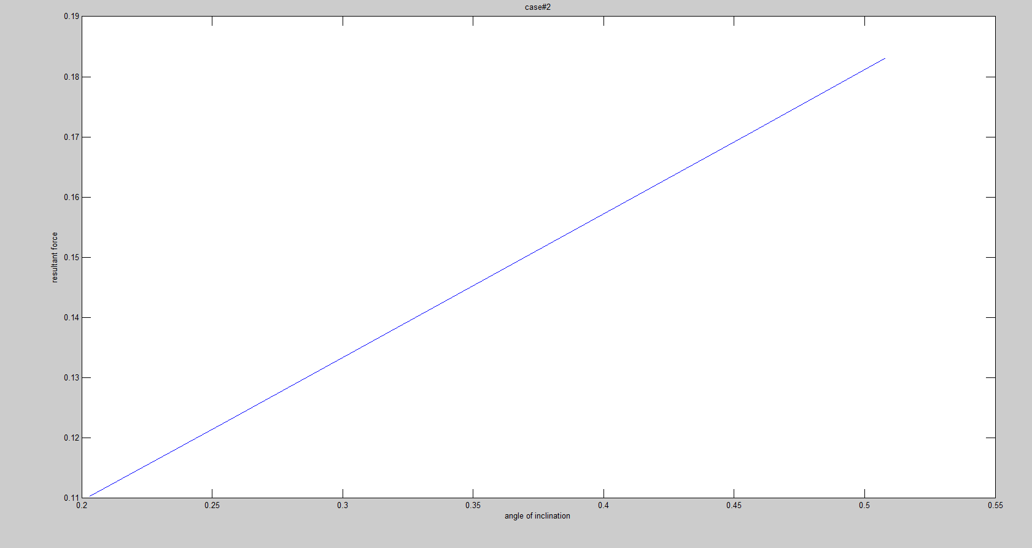
Figure 4

Discussion
For calculation of the resultant force acting on a submerged plate the following formula is used:
$$Fr=γAyc$$
For calculation of yR & xR the following formulas are used:
$$yR=yc+\frac{Ix}{Ayc}$$
Where Ix is the moment of inertia about the centroid
For the case of circular plates: $yR=yc+\frac{Ix\sin^{2}θ}{Ayc}$
$$Ix=\frac{π}{64}D^{4}$$
Where D is the diameter of the circular plate.
For symmetrical plates:
$$xR=centroid of the plate on the x axis$$

Whereby $γ$ is the specific weight of the fluid in which the plate is submerged.
A is the area of the submerged plate.
And yc is the vertical height up to the centroid.
For the problem given in cases 1,2$3 the following calculations are done for Fr
$$A=πr^{2}$$
Where r is the radius of the circular plate.
$$centroid=rsinθ$$
Where θ is the angle of inclination
$$yc=centroid+h$$
Where h is the vertical height up to the point at which the plate area begins
$$γ=density×gravitational constant(g)$$

Case#1
Calculation of Fr
$$Fr=γAyc$$
$$γ=9.81×1000=9810N$$

$$A=π{(5×0.0254)}^{2}=0.050670747m^{2}$$
$$yc=\left(5×0.0254\right)sinθ+\left(38×0.0254\right)=0.127sinθ+0.9652$$
$$Fr=63.129sinθ+479.78164$$
Calculation of yR:
$$yR=yc+\frac{Ix\sin^{2}θ}{Ayc}=0.127sinθ+0.9652+\frac{0.000204317sinθ^{2}}{0.006435183sinθ+0.0489}$$

The code
#case1 part a

%matplotlib inline
import matplotlib.pyplot as plt
import numpy as np
x1=np.linspace(20,45,5)
x=x1*0.017453292
Fr=497.746+63.124*(np.sin(x))
print(Fr)
plt.plot(x,Fr)

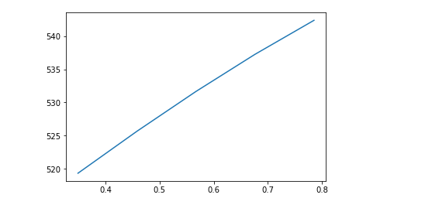
#case 1 part b
D=0.254
yc=0.9652+(0.127*(np.sin(x)))
yR=yc+((0.00403225/yc)*(np.sin(x))**2)
print(yR)
plt.plot(x,yR)

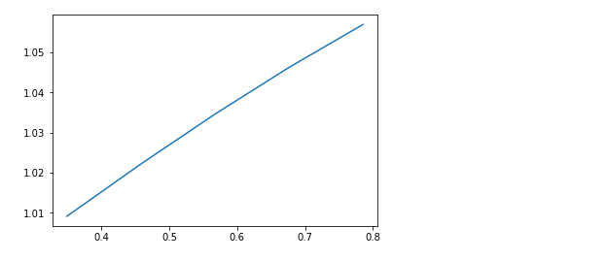

case #2
calculation of Fr
$$Fr=γAyc$$
$$γ=0.915×9810=8976.15$$
$$A=π({\frac{D}{2})}^{2}=0.78539816D^{2}$$
$$yc=h+\left(\frac{D}{2}\right)sin30=0.9652+0.25D$$
$$Fr=6804.516855D^{2}+1762.462923D^{3}$$
Calculation of yR
$$Ix\sin^{2}θ=\frac{π}{64}D^{4}\sin^{2}30=0.012271846D^{4}$$
$$yR=yc+\frac{Ix\sin^{2}θ}{Ayc}=\frac{A{yc}^{2}+Ix\sin^{2}θ}{Ayc}=\frac{A\left(0.93161104+0.4826D+0.0625D^{2}\right)+0.01227184D^{4}}{A(0.9652+0.25D)}$$

$$yR=\frac{0.73169D^{2}+0.379033D^{3}+0.0490874D^{4}}{0.7581D^{2}+0.1963495D^{3}}$$

#case 2 part a

d2=np.linspace(8,20,7)
D2=d2*0.0254
Fr2=(6804.516855*(D2**2))+(1762.462923*(D2**3))
#Fr2=6804.5*(D2)**2+561.0094*(D2)**3
plt.plot(d2,Fr2)
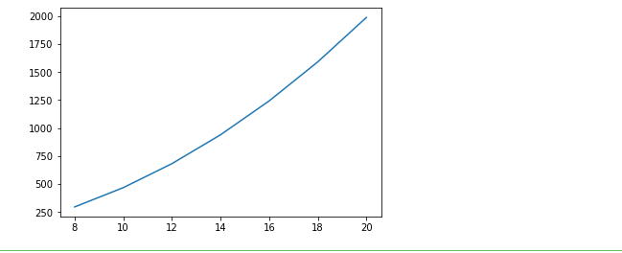

#case 2 part b
a=(0.73169*(D2**2))+(0.379033*(D2**3))+(0.0490874*(D2**4))
#a=3.8608+15.4432*D2+4.25*(D2)**2
b=(0.7581*(D2**2))+(0.1963495*(D2**3))
#b=61.7728+16*D2
yR2=a/b
plt.plot(d2,yR2) 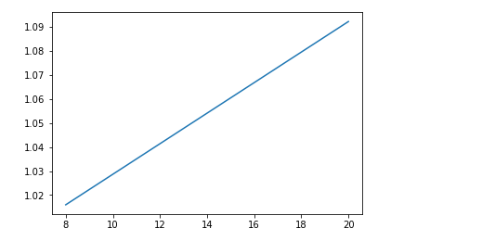

problem 2
The following are the calculation of the for question 2:
$$Fr=γAyc$$
$$γ=1.06×9810=10398.6N/m^{2}$$
$$A=0.5πr^{2}=0.5π{0.4575}^{2}=0.328777m^{2}$$
$$yc=h+centroid=h+\frac{4r}{3π}sinθ=0.305(20+57sin65+\frac{4r}{3π}sin65)=22.03214m$$

Therefore $Fr=$75323.925N

$yR=yc+\frac{Ix\sin^{2}θ}{Ayc}$

$$Ix=\frac{π}{8}r^{4}=0.017204$$
$$yR=22.03214+\frac{0.017204\sin^{2}65}{0.328777×22.03214}=22.034$$
For 90 degrees the plate is vertically oriented the value of Fr is the same as that calculated above.
On the other hand, $yR=yc+\frac{Ix}{Ayc}=22.03214+\frac{0.017204}{0.328777×22.03214}=22.034515$
for 180 degrees the plate will be horizontally oriented hence $Fr=hρgA=22.685×1.06×9810=235896.738N$
$yR=h=0.305\left(60sin65\right)+20×0.305=22.6854$m
The difference =0
The one flipped over by 180 has the greatest value of Fr.

